Vehicle Return Condition Report
Complete Submission

Make / model | Nissan Qashqai
Registration | WN 7020U
Mileage | 59 650 km
Return date | 30 August 2026
Returning driver | Michael Carter
Fuel level | 3/4 tank

1. Under the bonnet
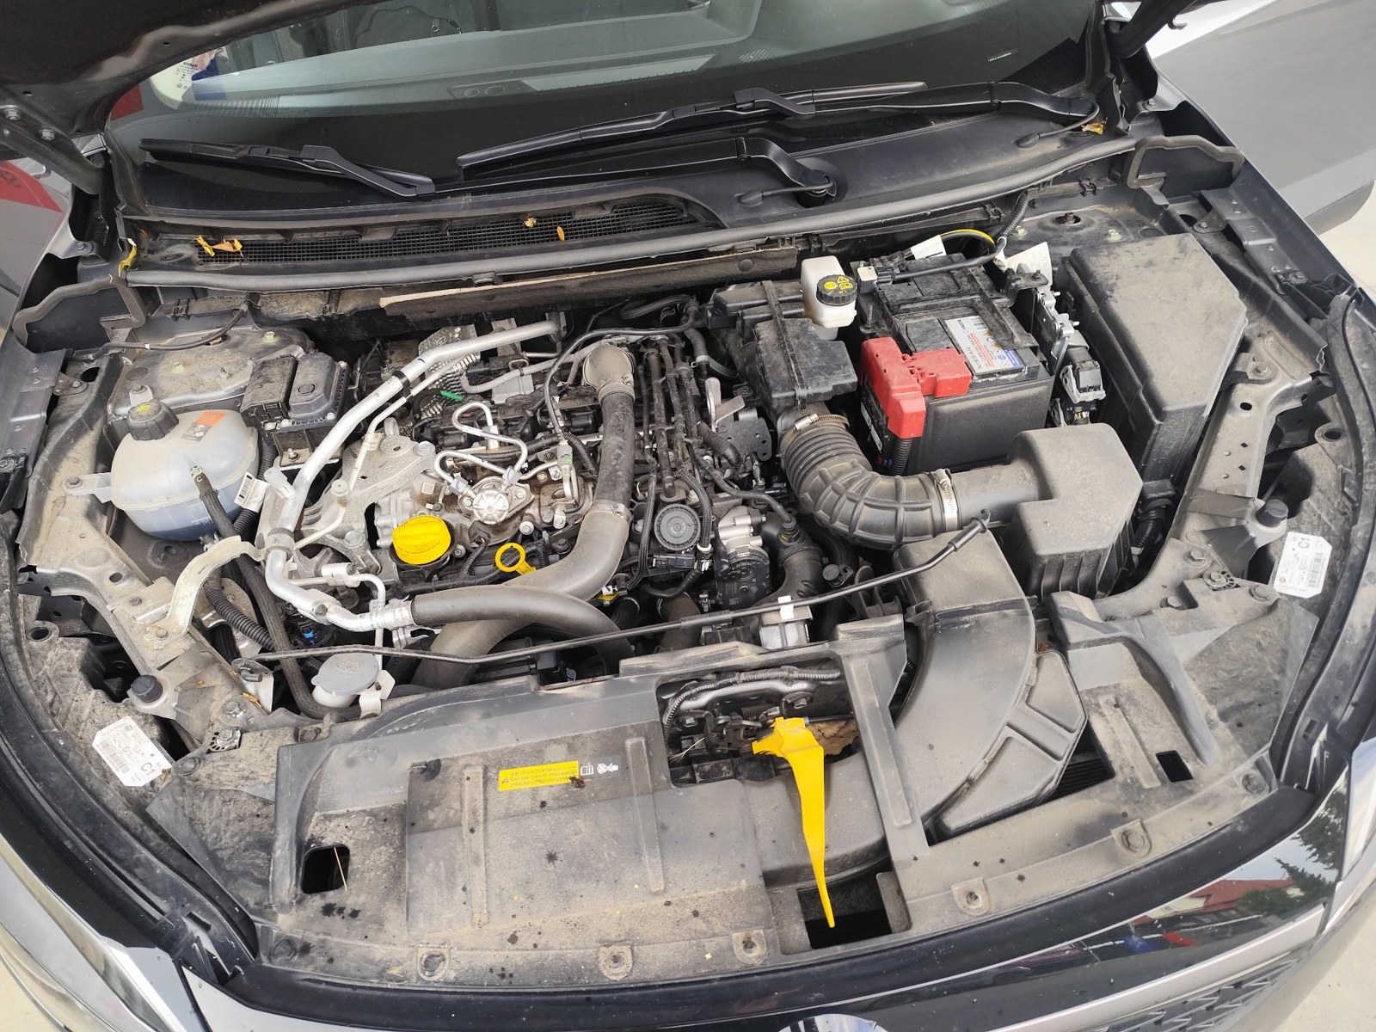
Engine bay, bonnet open

2. Seats
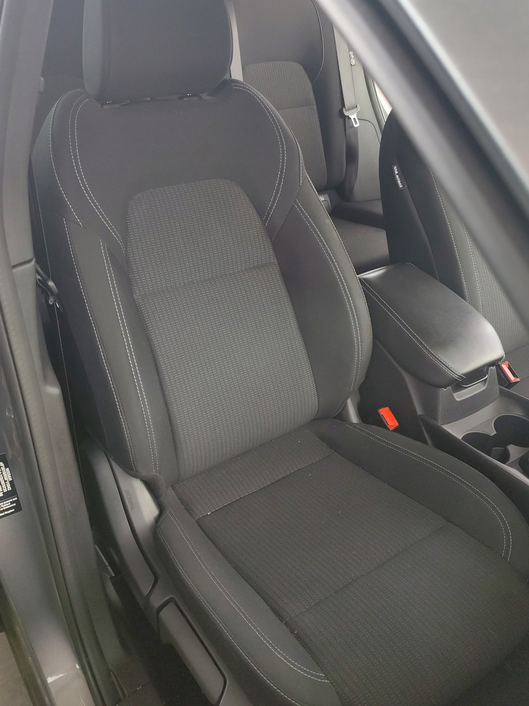
Seat 1
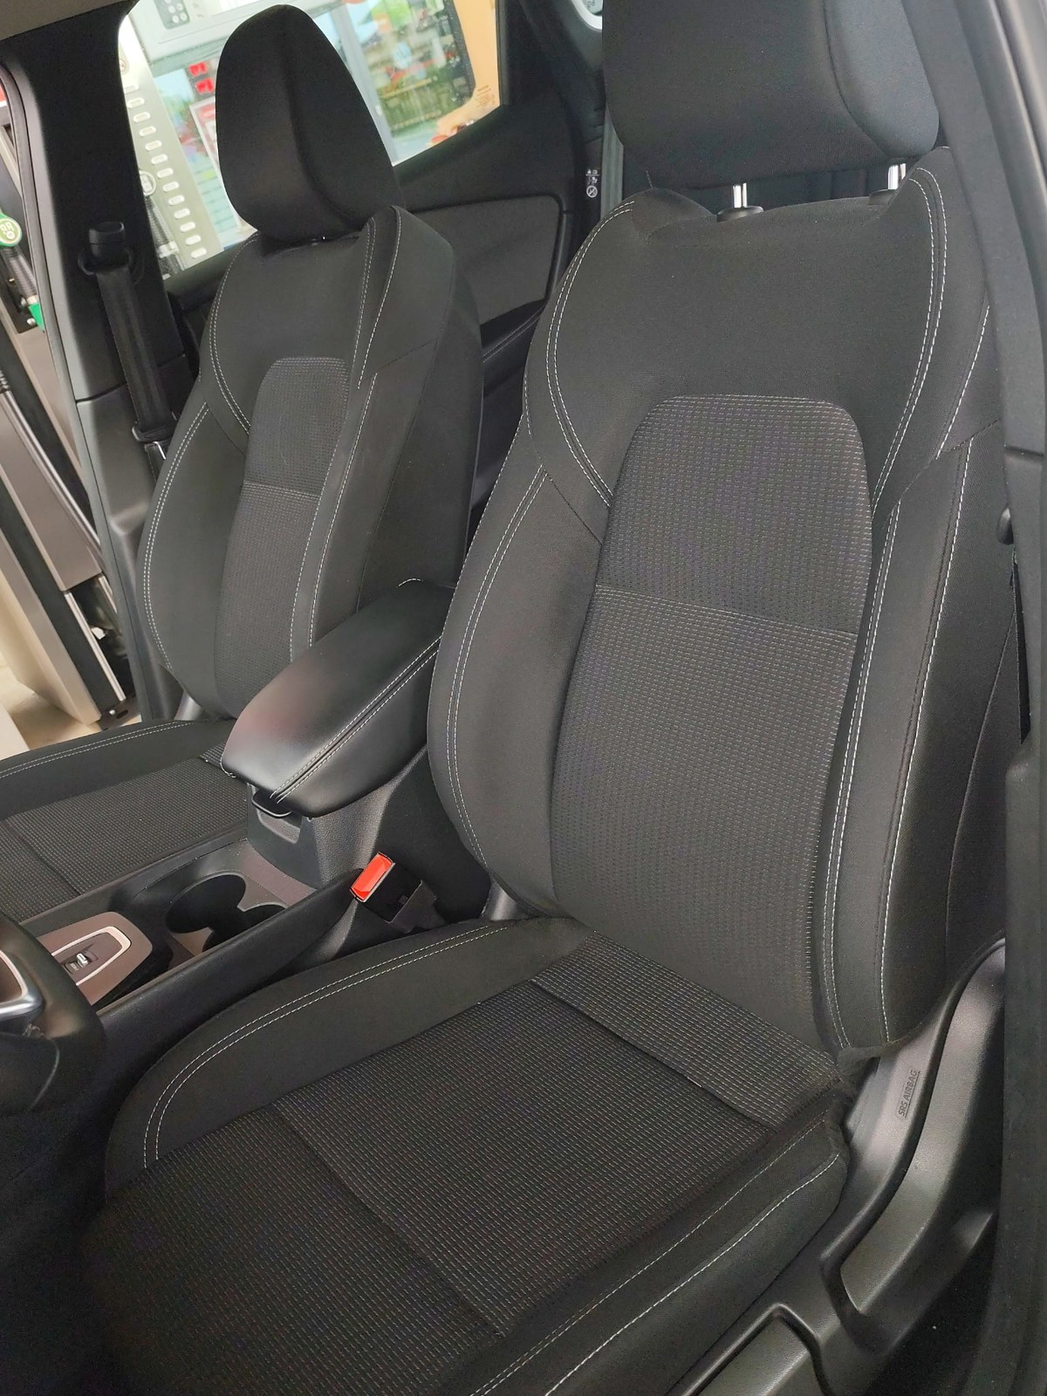
Seat 2
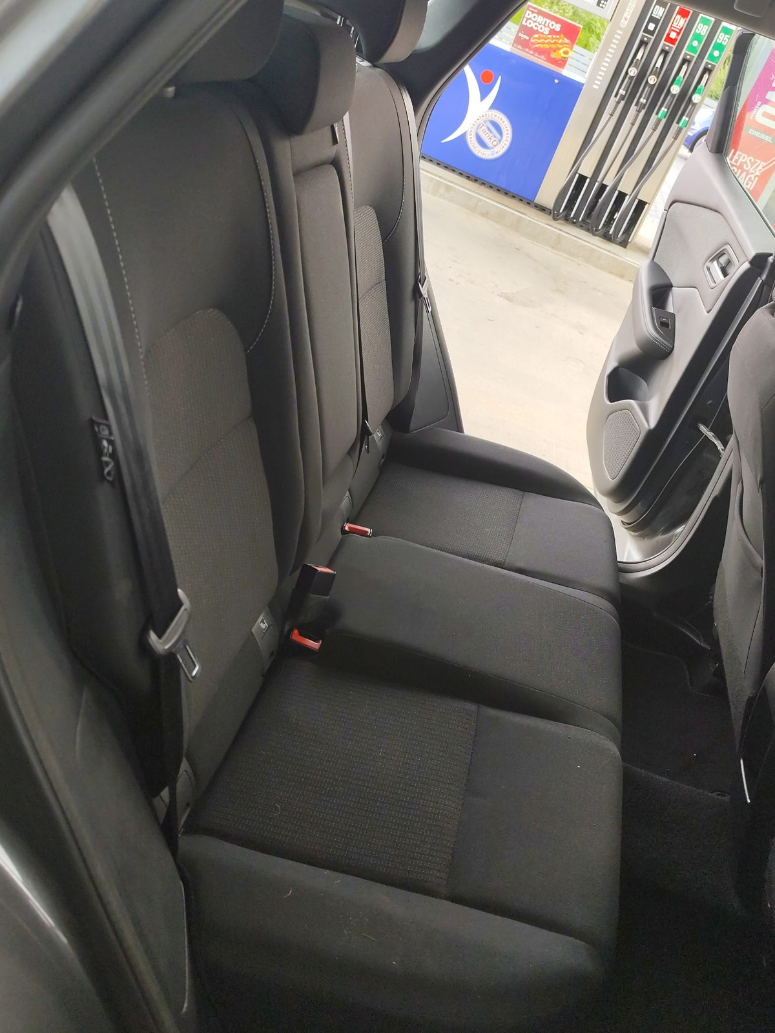
Seat 3
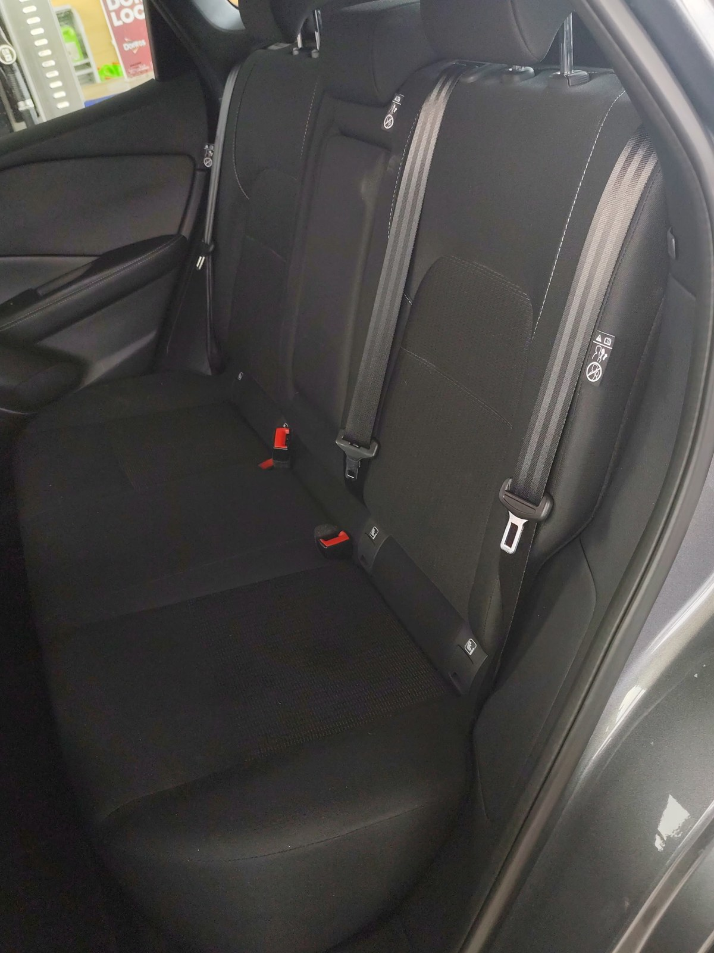
Seat 4

3. Vehicle diagonals
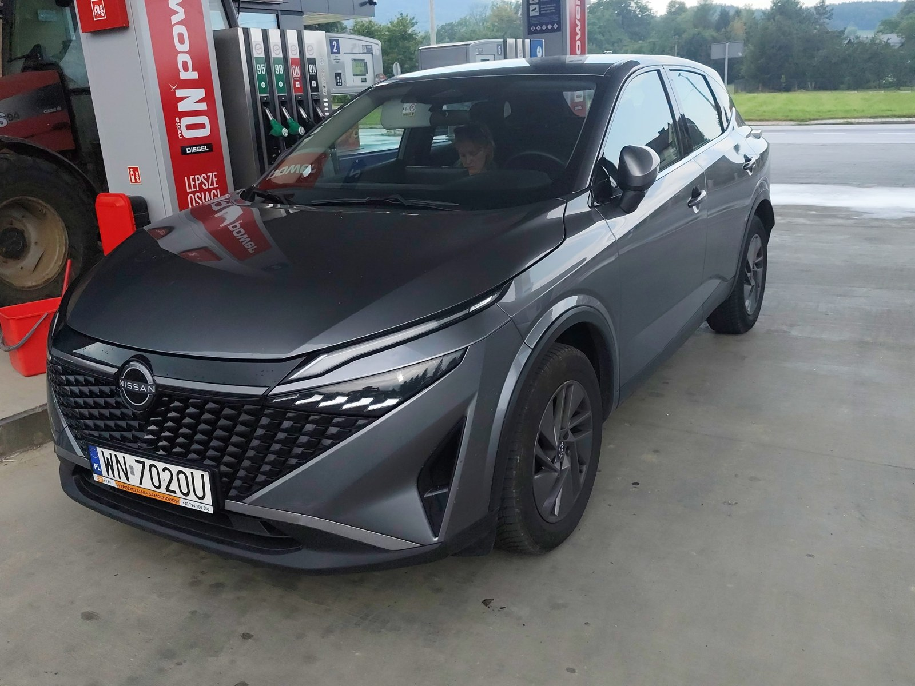
Diagonal 1

Diagonal 2

4. Headliner
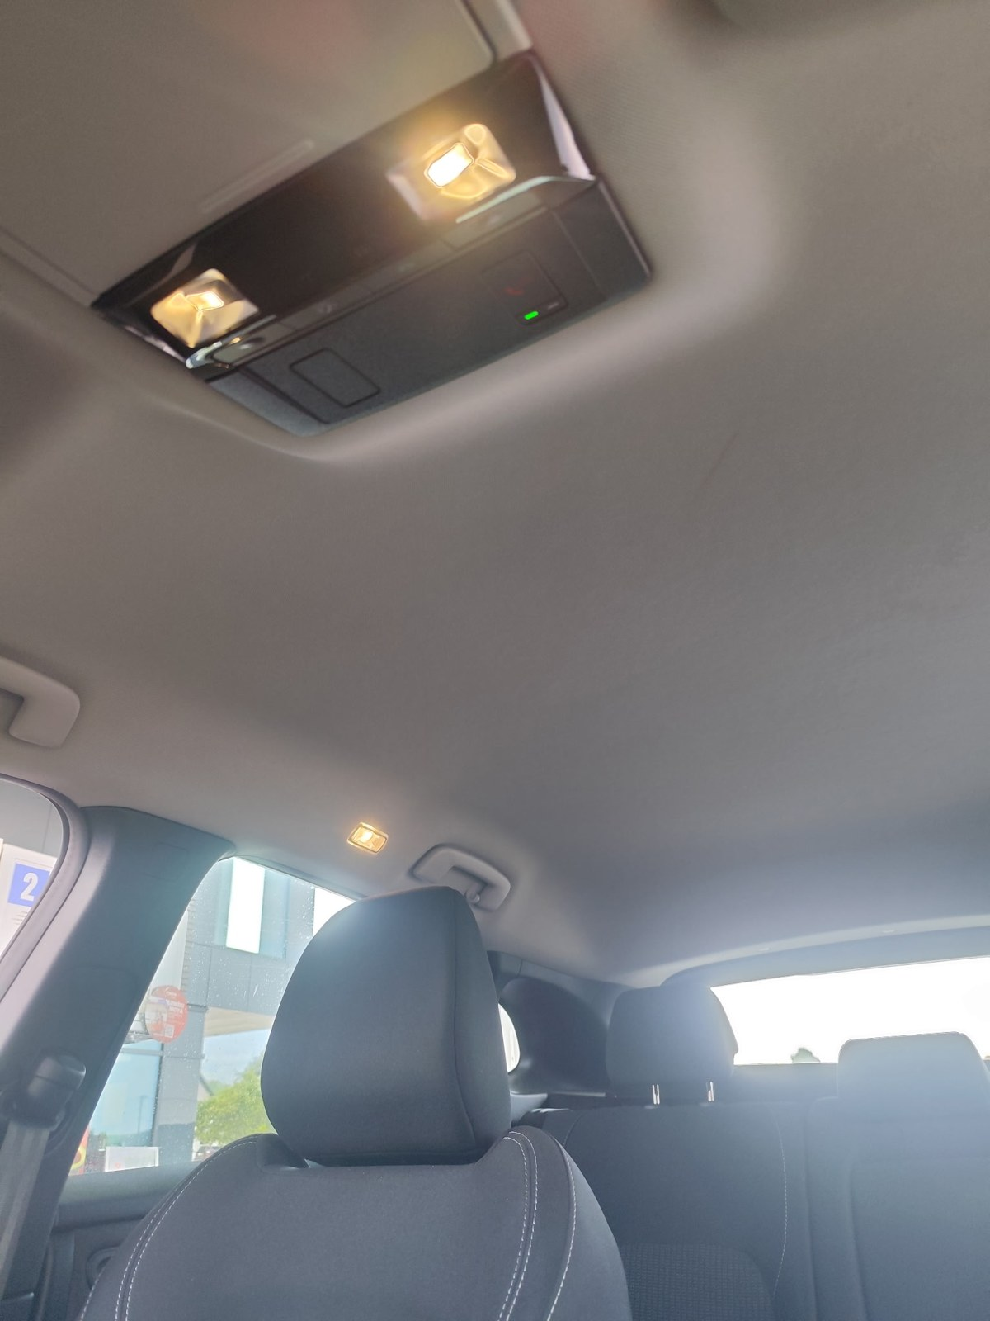
Headliner, from between the front seats
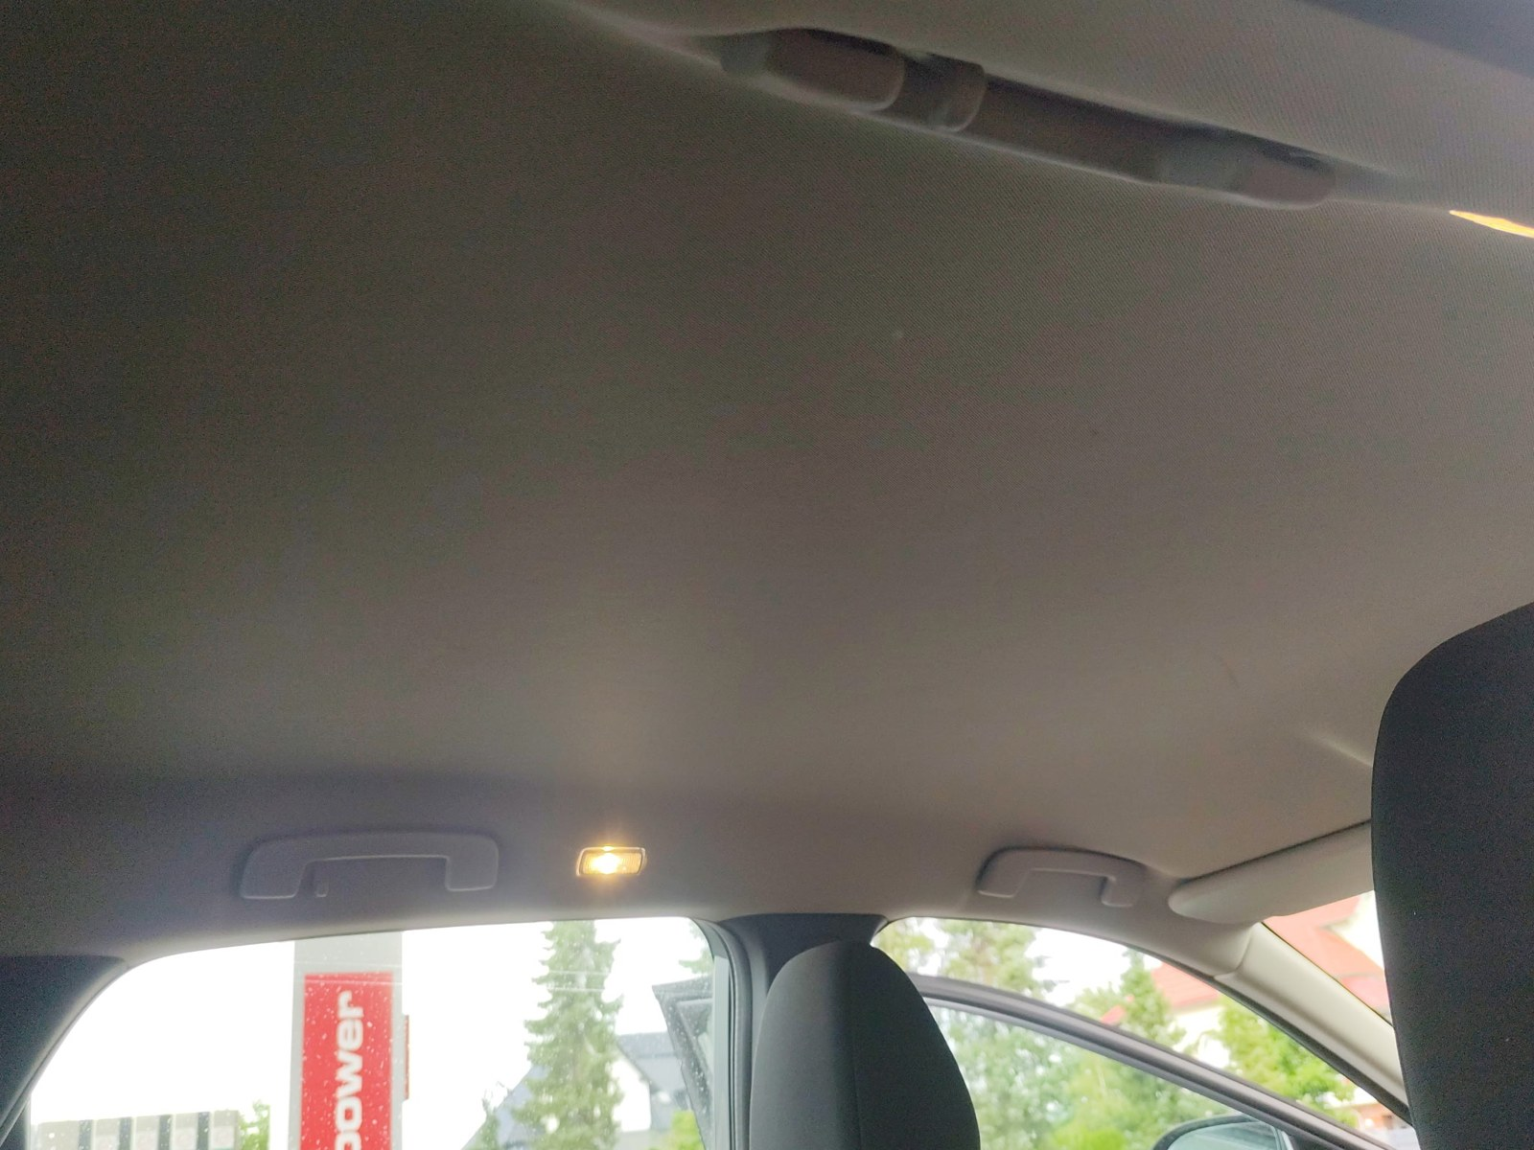
Headliner, second angle

5. Windscreen

Windscreen, from inside
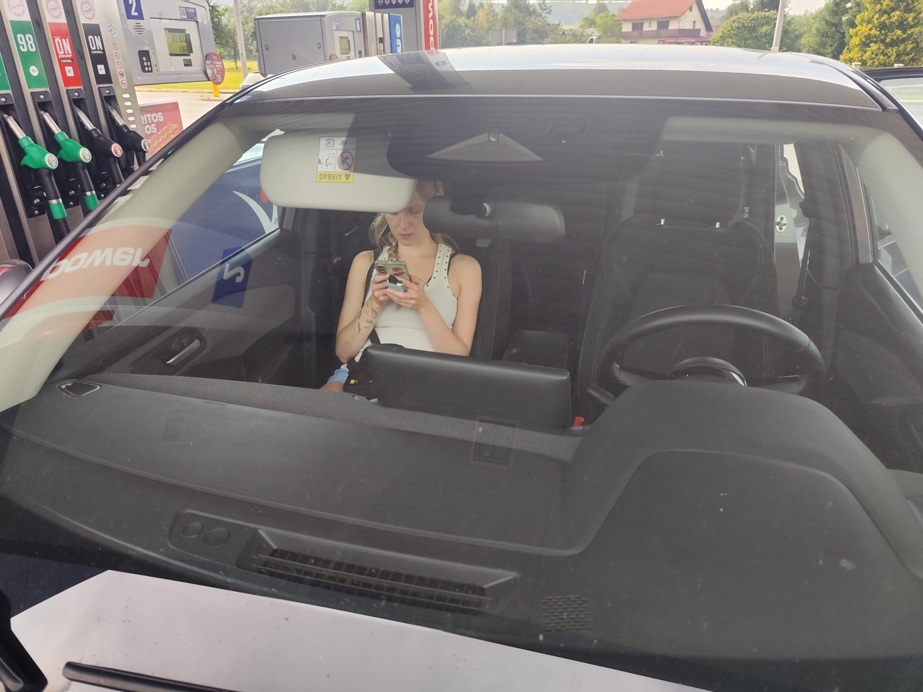
Windscreen, from outside

6. Tyre tread
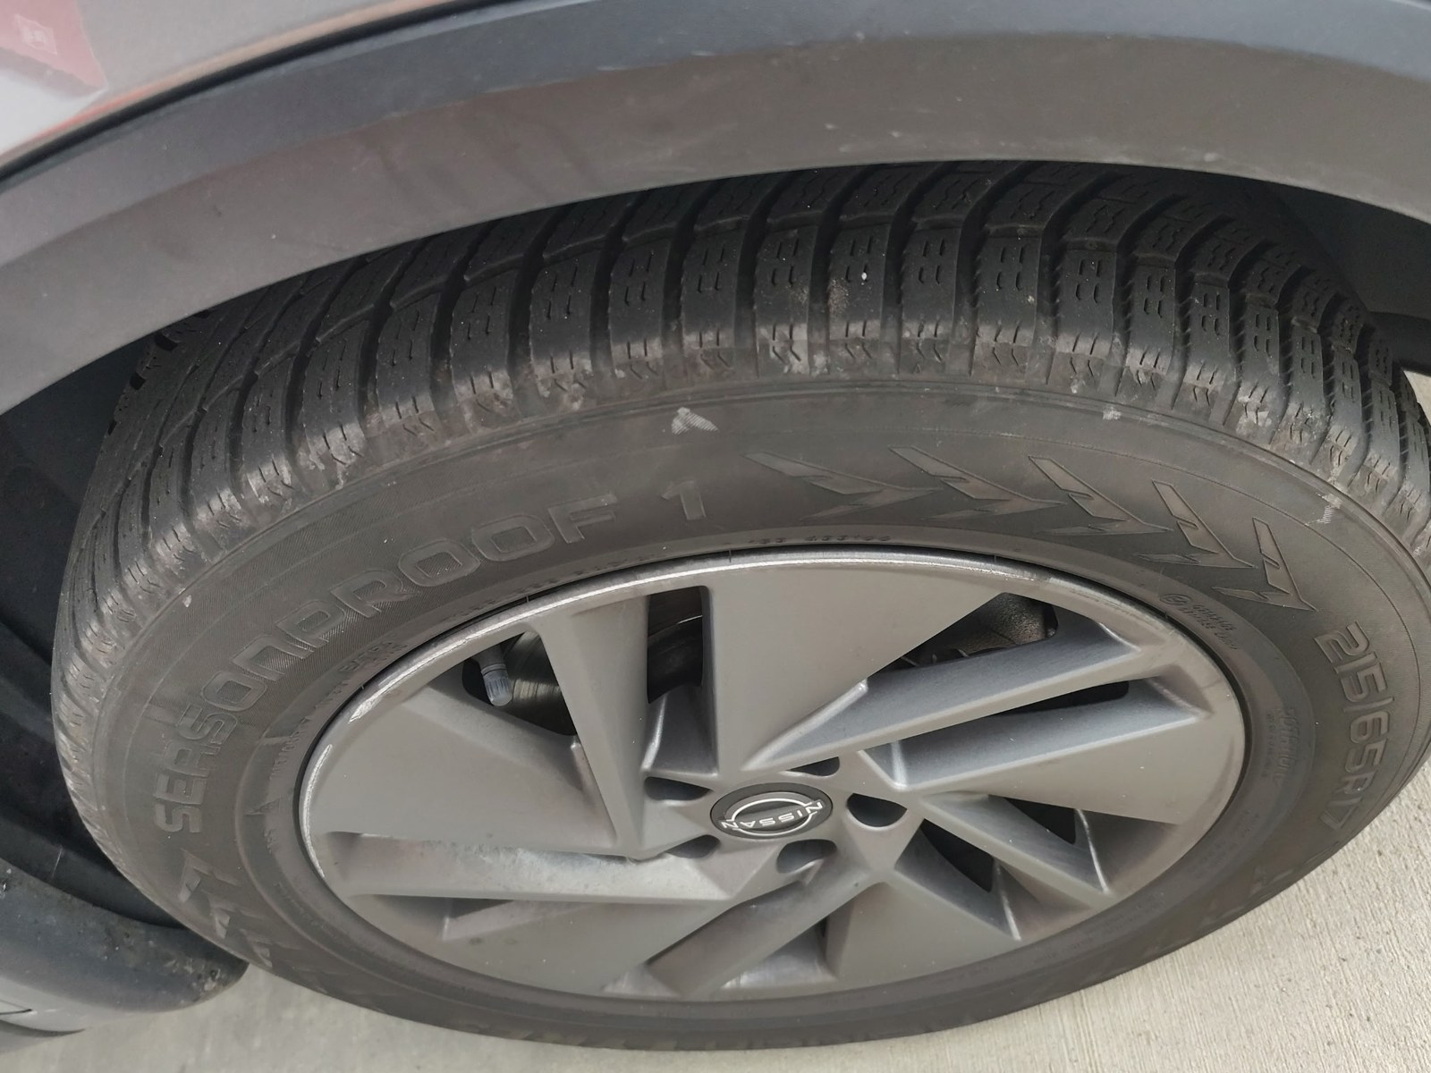
Tyre tread

7. Boot and equipment
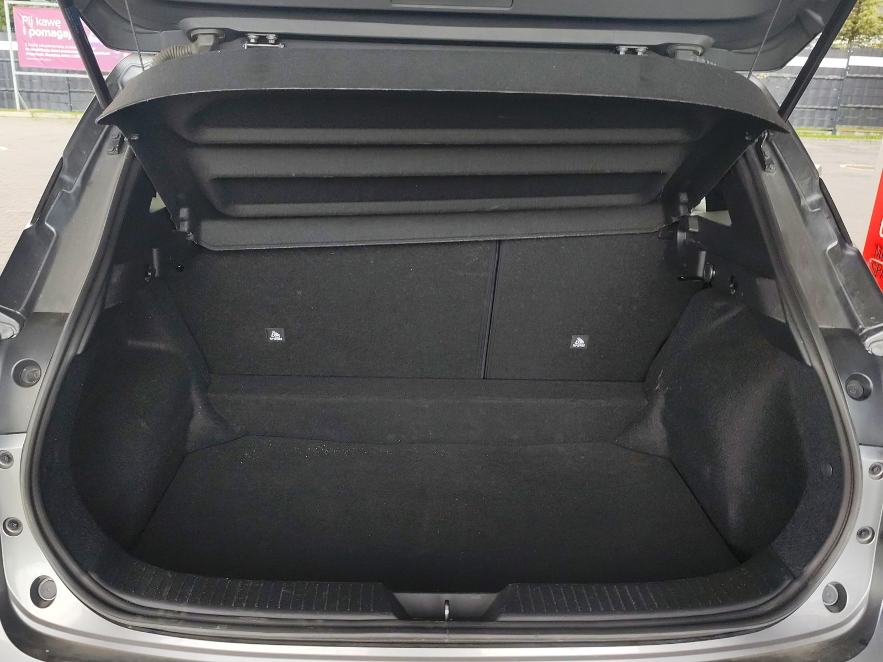
Boot, open
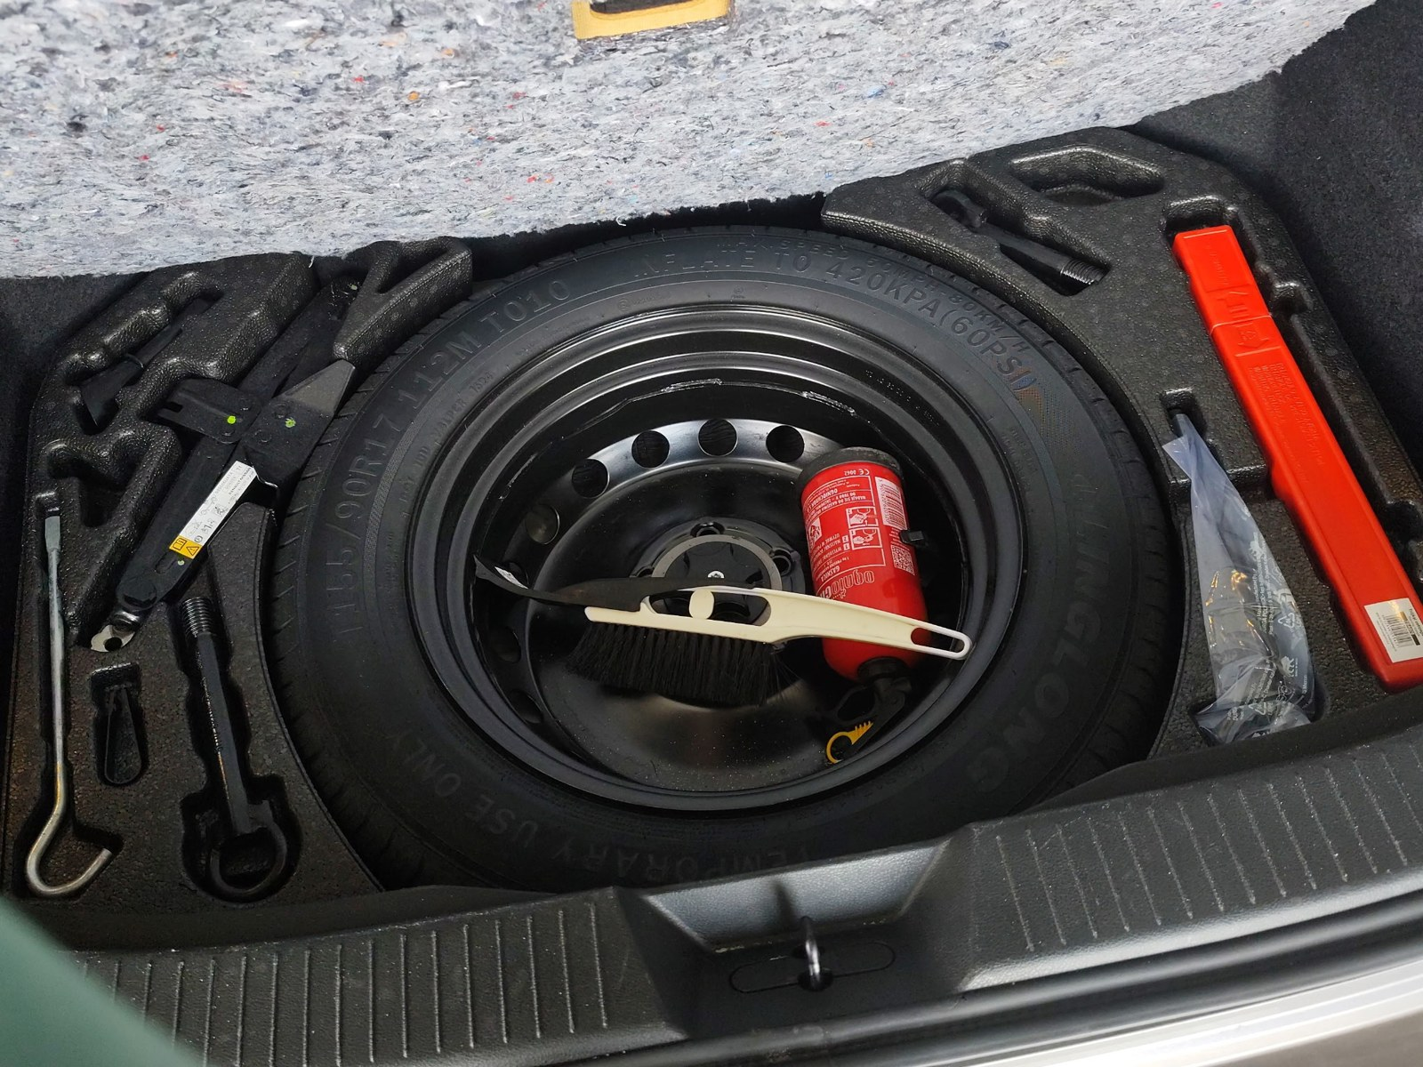
Equipment under the boot floor

8. Gauges
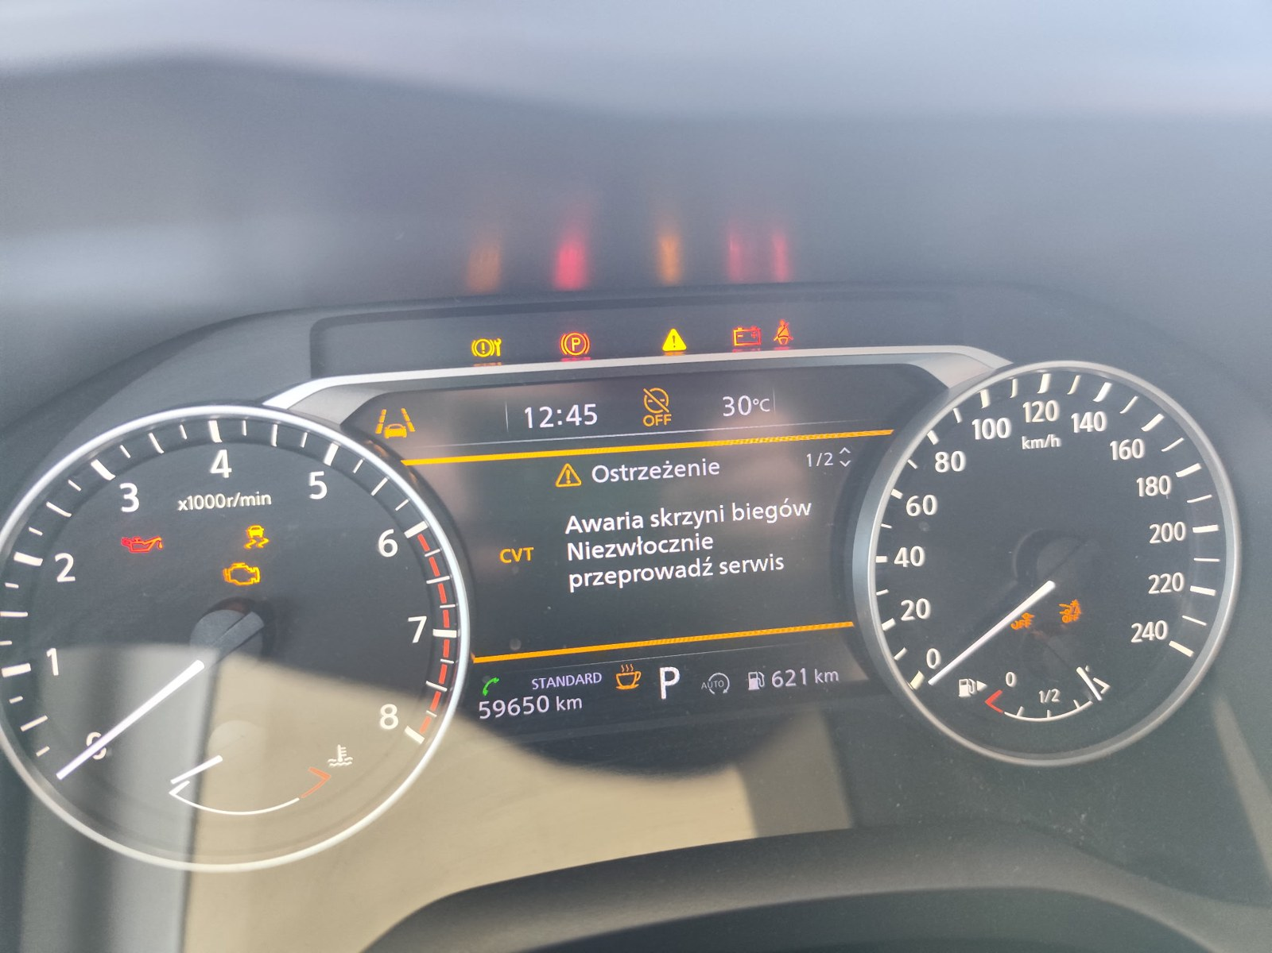
Instrument cluster

9. Notes
1x spare key, phone charging cable, service book, registration certificate.

────────────────────────────────────────
Prepared via Amendo · Vehicle Return Condition Report

